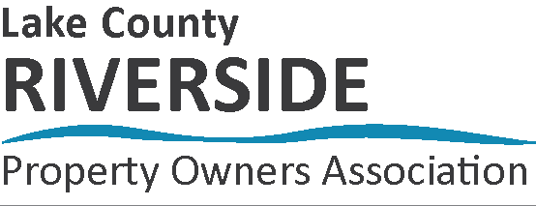

BOY SCOUTS OF AMERICA ANNUAL PM RIVER CLEAN UP REGISTRATION FORM

August 4, 2022

PLEASE REGISTER AS A UNIT

Total Youth Participants:
Total Adult Participants:
Unit#: District:

CAMPING: (Please check the box) YES:  NO:  DAYS: WEDNESDAY:  THURSDAY: 

Adults in Charge:

Name: Email:
Address:
Home Phone: Cell Phone:

Name: Email:
Address:
Home Phone: Cell Phone:

All Participating Scout Names: (Please list below):

PLEASE PRINT AND RETURN COMPLETED REGISTRATION FORM BY JULY 10, 2022 TO:

LCRPOA Attn: PM Clean Up, PO Box 13, Baldwin, MI 49304 or email lcrpoa.org@gmail.com

