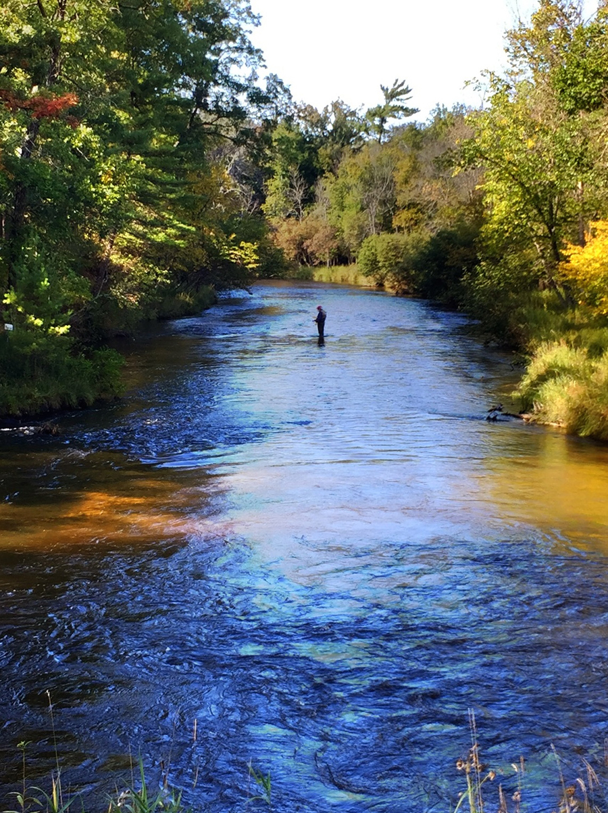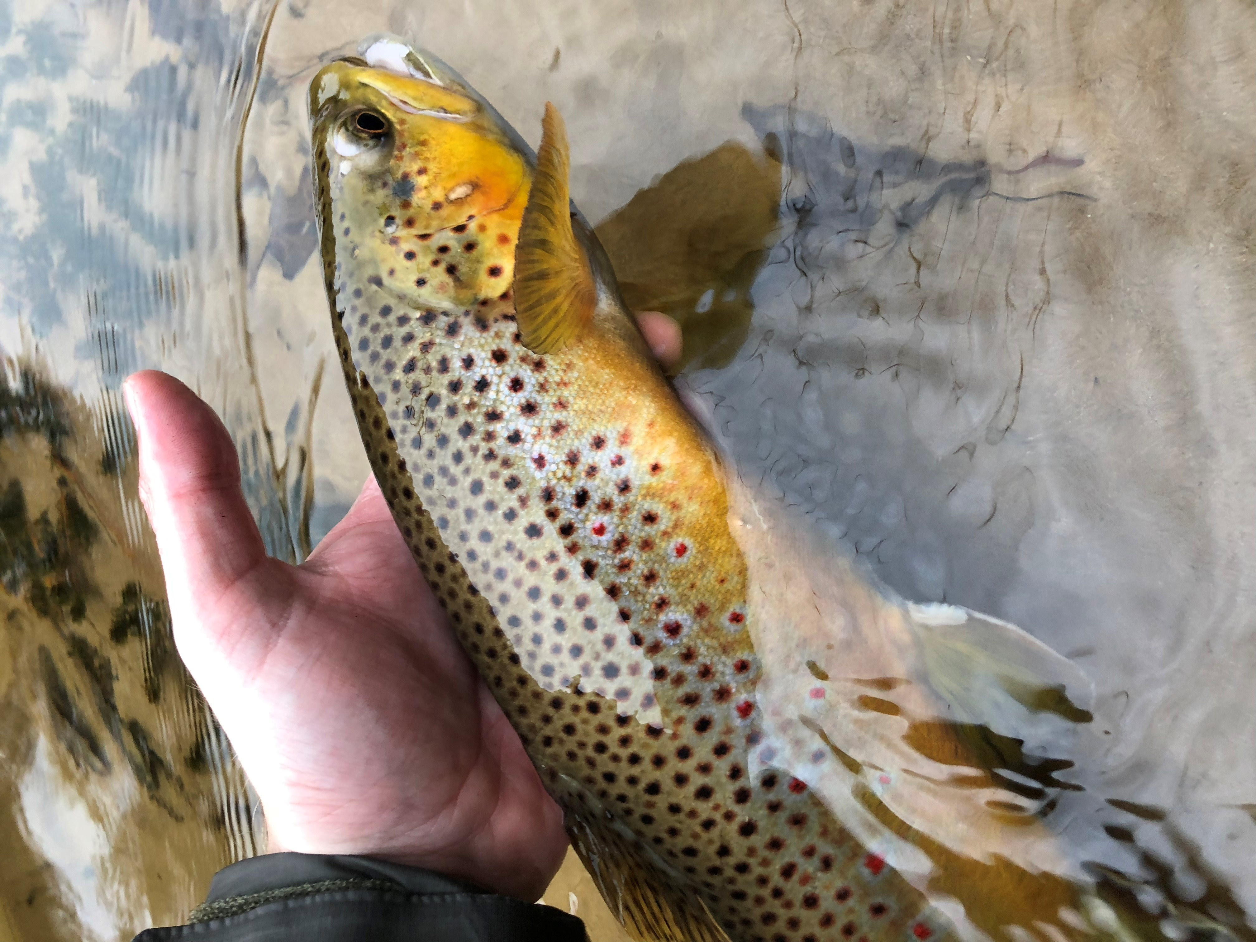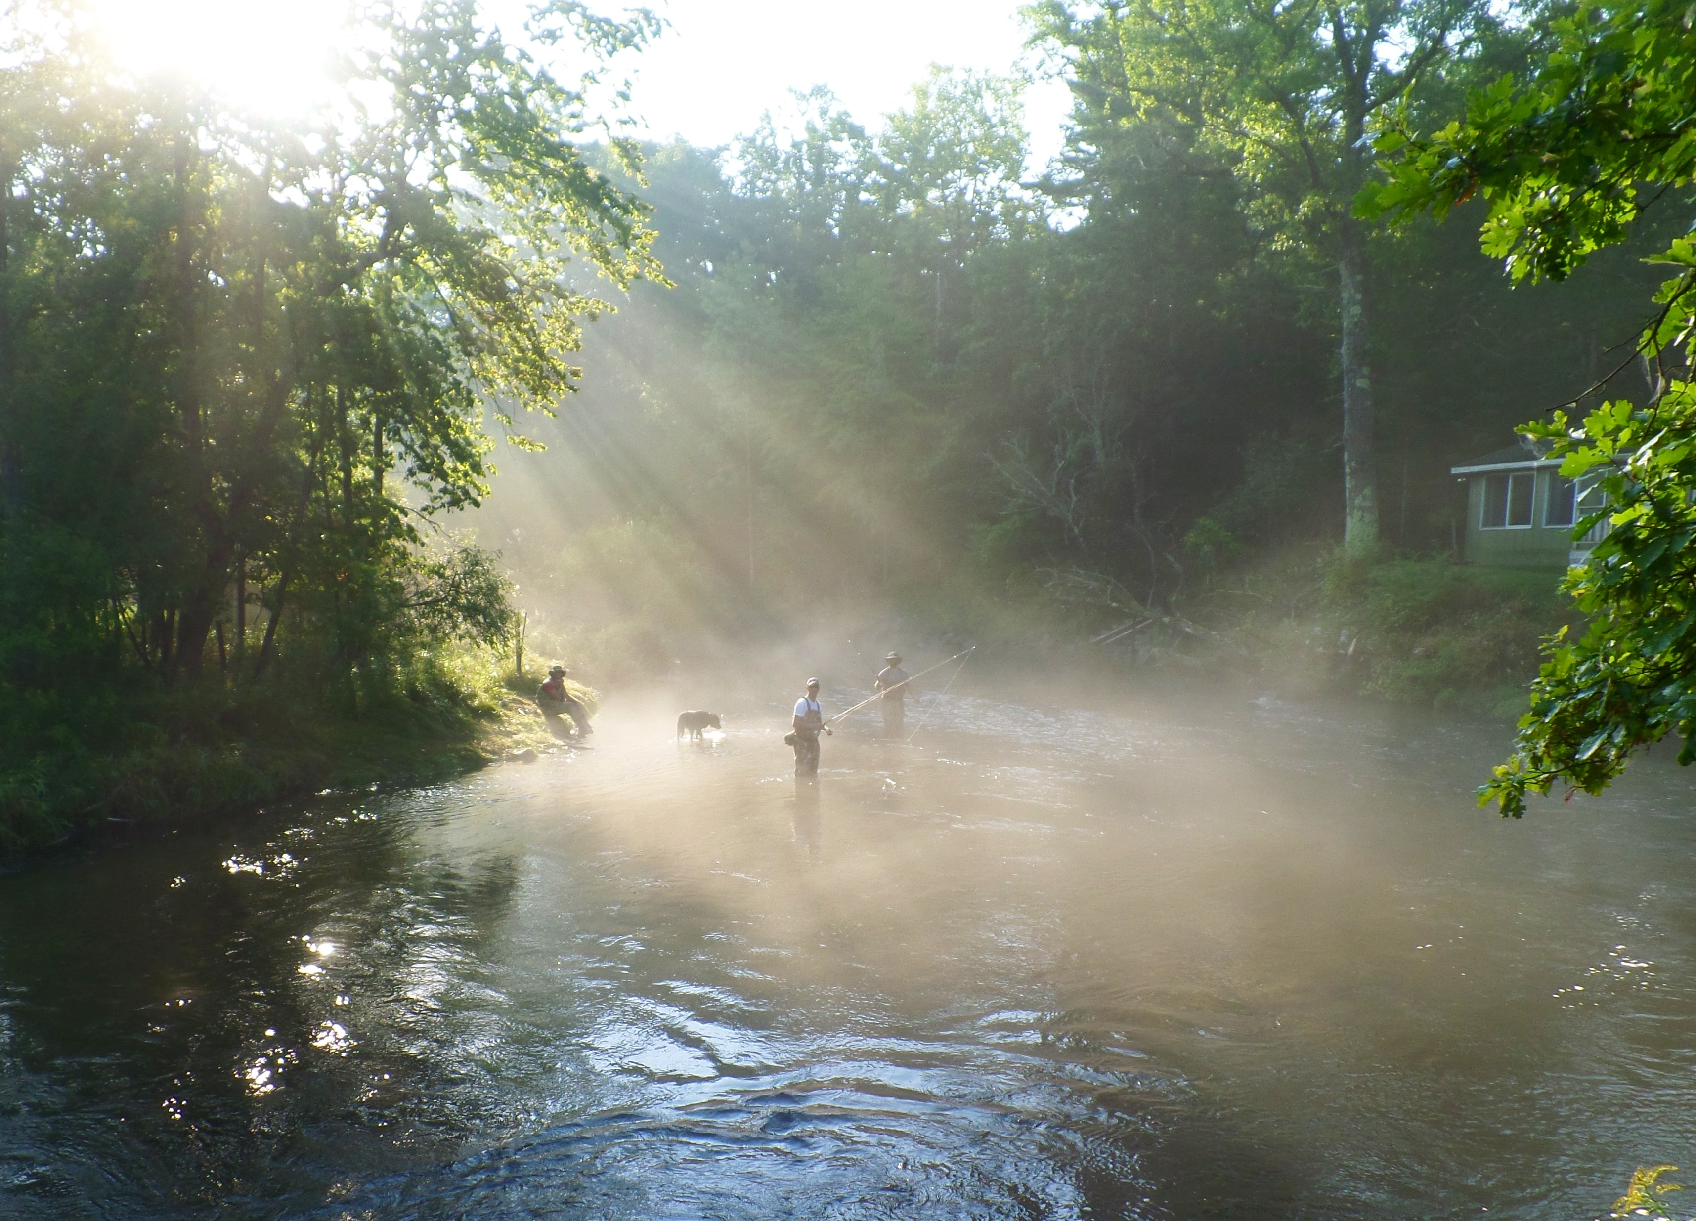

**Yes, I want to join the LCRPOA!**

**Name _______________________**

**Street ______________________**

**City ________________________**

**State _________ Zip __________**

**Home Phone _________________**

**Mobile Phone ________________**

**Email _______________________**

**River _______________________**

Add MLSA Riparian Mag Y or N

Baldwin, Michigan

[*www.lcrpoa.org*](http://www.lcrpoa.org)

**Individual Membership**

$35.00 Yearly Dues

$50.00 W/Riparian Magazine

**Club Membership**

$50.00 Yearly Dues

**Lifetime Membership**

$500.00

**Thank you for your support!**

***If you have any questions please contact us at: lcrpoa.secy@lcrpoa.org***

* Support the US Forest Service Non- Native Invasive Species Initiative to reduce non-native vegetation along the river.
* Work closely with the USFS to monitor the PM River Management plan and Hazardous Fuels program in Lake County.
* Member of the Natural Rivers Zoning Review board.
* Provide an “Approved Provider List” of local service providers.
* Host Annual Luncheon Meeting in July with updates from key resources and guest speaker.
* Provide MLSA Riparian Magazine
* Sponsor the annual Boy Scout Clean-up of the most heavily traveled stretches of the Pere Marquette River.
* Partner with the PM Watershed Council sponsoring summer interns to monitor river behavior and report incidents requiring action.
* Work closely with the Lake County Sherriff Department through the Silent Observer and Property Identification programs to protect association member property and facilitate quick response when required.
* Publish the Lake County Riverbank Watch newsletter.

### **What We Do on Behalf of our Membership:**

**Rivers We Serve**

Pere Marquette

Little Manistee

Little Sable

Pine

*Plus their tributaries*

The purpose of the Lake County Riverside Property Association is to represent, promote and support the interests of property owners on the rivers and streams in Lake County in all matters affecting their rights of ownership, use and enjoyment of their property, recognizing that the rivers and streams are pubic domains open to many, often competing, users. The following commitments of the association include:

* Ensure properties and the rivers /streams remain safe and secure from user and/or environmental abuse.
* To monitor, propose and actively promote local, state and federal legislation and regulations that benefit property ownership as well as oppose any that would adversely affect property owners’ interests.
* To communicate to and mobilize property owners to act/react if adversely affected.
* To support and promote efforts by law enforcement agencies and others.
* To educate users on acceptable rules of use and conduct.

# **Our Mission**